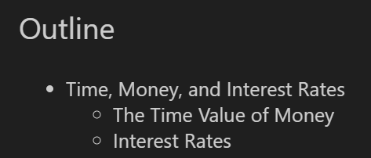

**The timeline**

The timeline is a visual representation of a series of cash flows over time.

**For example:** If you must pay tuition of $10,000 per year for the next two years, payable in equal installments at the start of each semester, the timeline would illustrate these payments and their timing.

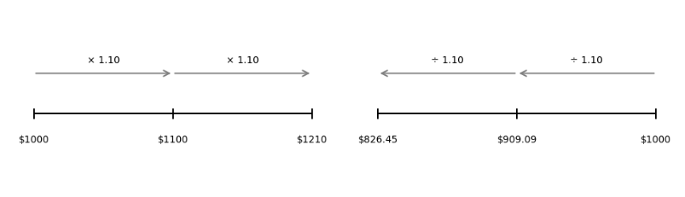

**Left side: (Future Value Growth)**

* Starting at $1000
* Each period multiply by 10% (means a 10% growth per period)

| **Period** | **Formula** | **Result** |
| --- | --- | --- |
| 0 | $1000 | $1000 |
| 1 | $1000 × 1.10 | $1100 |
| 2 | $1100 × 1.10 | $1210 |

* After 2 periods, the amount grows to $1210

**Right side: (Present value discounting)**

* Want to have $1000 in the future => caculate how much it is neccessary to invest today if the interest rate is 10% per period
* Each period divided by 10% (discounting back to PV)

| **Period** | **Formula** | **Result** |
| --- | --- | --- |
| **0** | **$1000 ÷ 1.10** | **$909.09** |
| **1** | **$909.09 ÷ 1.10** | **$826.45** |

* If we invest $826.45 today, after 2 periods at 10% interest rate, it will end up with $1000.

**Three rules of time travel:**

* Compare or combine values only at the same point in time.
* Move cash flows forward by compounding (multiplying by a growth factor, e.g., 10%).
* Move cash flows backward by discounting (dividing by a growth factor).

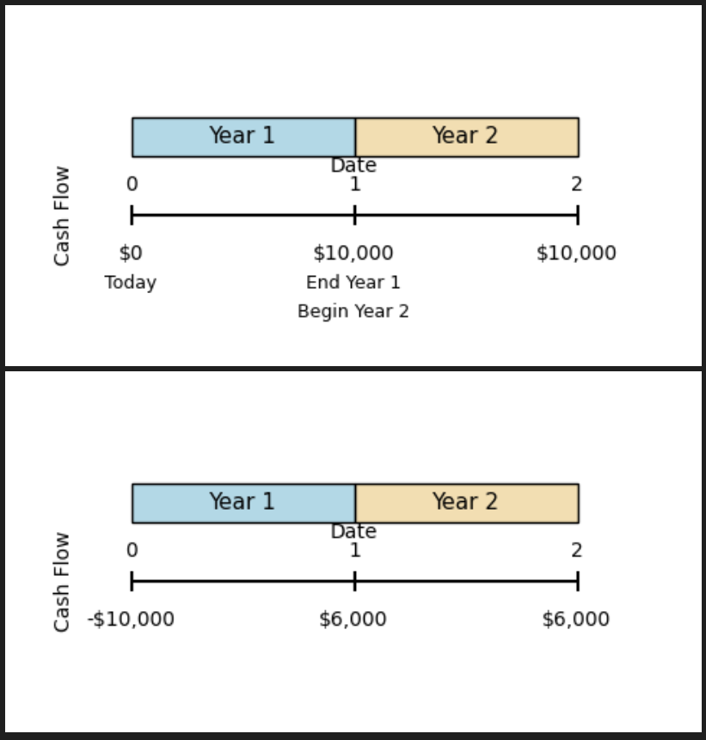

**Description:**

* **Top Diagram:**
* Having $0 today (year 0)
* At the end of Year 1 (or beginning of Year 2) you receive $10,000
* At the end of Year 2 you receive another $10,000
* **Bottom Diagram:**
* At Year 0 (today) you invest $10,000 (negative cash flow: -$10,000)
* At the end of Year 1, you receive $6,000
* At the end of Year 2, you receive another $6,000

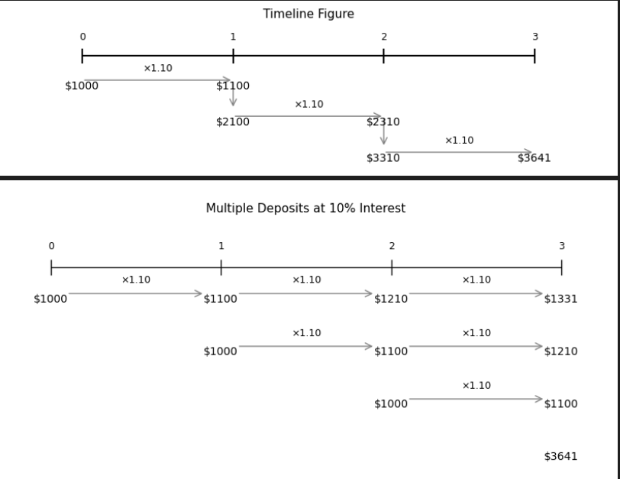

**Timeline Figure (annuity with compound interest)**

* You deposit $1000 every year. (Add $1000 every year)
* Each deposit earns 10% interest (compounded annually).
* After 3 years, the total grows to $3641.

**Bottom Figure (annuity)**

• Shows how each $1000 deposit grows separately:

* Year 0 deposit: $1000 → after 3 years gain $1331
* Year 1 deposit: $1000 → after 2 years gain $1210
* Year 2 deposit: $1000 → after 1 year gain $1100

• Total after 3 times deposit: $1331 + $1210 + $1100 = $3641.

* Both figures describe the ***same result*** using different views.

|  |
| --- |
| Annual interest rate = (1 + r.semiannual )^2 - 1 |

**Valuing a stream of cash flows - Annuity** (emphasizing the importance of payment timing (beginning vs. end of the period)

1. **Timing Matters:**

* Payments made at the beginning of a period (annuity due) earn interest sooner than those made at the end (ordinary annuity).
* Standard formulas apply to regular payments made at regular intervals.
* 2 types: Ordinary Annuity (trả cuối kỳ) and Annuity Due (trả đầu kỳ)

1. **Future Value (FV) Formulas:**

**Future value of Ordinary Annuity (Paid at the end of each period)**

|  |
| --- |
| **FV = CF [$\frac{{(1+ i)}^{n}- 1}{i}]$** |

Meaning:

* Mỗi kỳ bạn nộp CF, nộp xong mới tính lãi.
* Sau n kỳ, tổng số tiền bạn có ở cuối kỳ n.

**Future value of Annuity Due (Paid at the beginning of each period)**

|  |
| --- |
| **FV = CF [$\frac{{(1+ i)}^{n}- 1}{i}]*(1$ + i )** |

Meaning:

* Mỗi kỳ bạn nộp CF ngay đầu kỳ, nên mỗi khoản đều có thêm 1 kỳ lãi.
* Khác với Ordinary Annuity: có thêm nhân ( 1 + i)

1. **Present Value (PV) Formulas:**

**Present value of Ordinary Annuity (Paid at the end of each period) – Annual formula**

|  |
| --- |
| **PV = CF $\left(\frac{1- ({1+ i )}^{-n}}{i}\right)$\*** |

Meaning:

* Tính giá trị hiện tại của chuỗi tiền CF được trả đều cuối mỗi kỳ trong n kỳ.
* Đây là công thức rất hay dùng để định giá khoản vay, trái phiếu, tiền tiết kiệm đều kỳ.

**Present value of Annuity Due (Paid at the beginning of each period)**

|  |
| --- |
| **PV = CF $\left(\frac{1- \frac{1}{({1+ i )}^{n-1}}}{i}\right)+ CF$\*** |

**Or**

|  |
| --- |
| **PV = CF $\left(\frac{1- \frac{1}{({1+ i )}^{n}}}{i}\right)*(1+ i)$\*** |

Meaning:

* Giống Ordinary Annuity nhưng vì trả đầu kỳ nên mỗi CF có thêm 1 kỳ lãi → nhân thêm (1+i)

|  |
| --- |
| **CF:** số tiền trả đều đặn mỗi kỳ (Cash Flow per period)  **i:** lãi suất mỗi kỳ (Interest rate per period)  **n:** số kỳ thanh toán (Number of periods) |

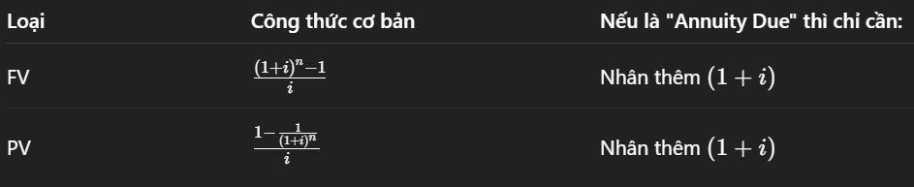

**Loan Amortization (học kỹ)**

**Suppose a business takes out a $25,000, five-year loan at 8%. The loan agreement calls for the borrower to pay the interest on the loan balance each year and to reduce the loan balance each year by $5,000.**

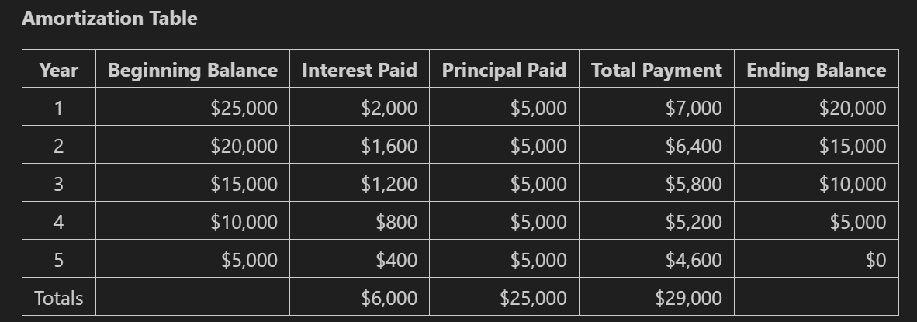

**Caculations:**

1. **Beginning Balance: The loan balance at the start of the year.**
2. **Total Payment: The sum of the interest paid and the principal paid for the year.**

|  |
| --- |
| **Total Payment = Interest Paid + Principal Paid** |

1. **Interest Paid:**

|  |
| --- |
| **Interest Paid = Beginning Balance × Interest Rate** |

1. **Principal Paid: Fixed at $5,000 per year.**
2. **Ending Balance: The remaining loan balance after the payment is made.**

|  |
| --- |
| **EndingBalance = Beginning Balance – Principal Paid** |

**Fixed Payment Loan (học kỹ)**

**Now assume that the borrower wants to make a fixed payment every period. What is the monthly payment amount that amortizes this loan fully at the end of the 5th year?**

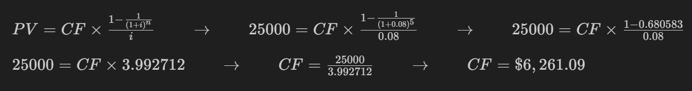

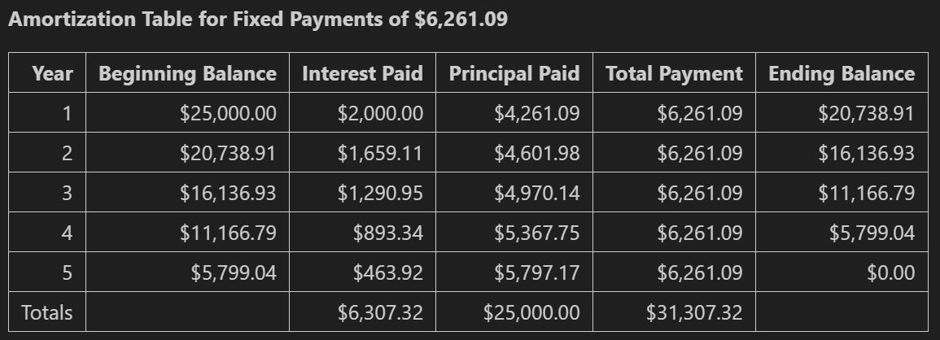

Interest = 8% x beginning balance

Principle = fixed payment - interest

Ending balance = beginning balance - principle

* Total payment is the same every year (payments are annual and equal)

**Perpetuity (vĩnh viễn)**

When a constant cash flow will occur at regular intervals forever it is called a **perpetuity**. The value of a perpetuity is simply the cash flow divided by the interest rate.

|  |
| --- |
| **PV (C in Perpetuity) = $\frac{C}{i}$** |

**Growing Perpetuity**

|  |
| --- |
| **PV (C in Perpetuity) = $\frac{C}{i- g}$** |

**Growing Annuity**

The present value of a growing annuity with the initial cash flow, C, growth rate, g, and interest rate, i, is defined as:

|  |
| --- |
| **PV (C in Perpetuity) = $\frac{C}{i- g}$ x $(1-{\left(\frac{1+ g}{1+ i} \right)}^{N})$** |

**Interest Rates**

**Annual Percentage Rate (APR)**

|  |
| --- |
| **APR = Periodic Rate × Number of Periods per Year** |

The amount of simple interest earned/paid in one year (the amount of interest earned/paid without the effect of compounding

* Does not reflect the true amount you will earn/pay over one year.
* Can't use the APR as a discount rate.
* APR becomes meaningful only if the compounding interval is given.

**Effective Annual Rate (EAR)**

The actual amount of interest that will be earned / paid at the end of one year.

|  |
| --- |
| **(1 + EAR) = ${\left(1+\frac{APR}{k}\right)}^{k}$** |

**Continuous Compounding**

There is no limit to how frequently interest could be paid.

Compounding every infinitesimal instant is called continuous compounding.

